

ANTIMICROBIAL RESISTANCE IN
NEISSERIA GONORRHOEAE
IN NEW ZEALAND: 2024

PREPARED FOR: | Ministry of Health
CLIENT REPORT No: | FW25027
PREPARED BY: | Health Intelligence and Surveillance Group
PUBLISHED: | 18 August 2025

This report is available at www.surv.esr.cri.nz

Published: 18 August 2025

Suggested citation:
The New Zealand Institute for Public Health and Forensic Science
Antimicrobial resistance in Neisseria gonorrhoeae in New Zealand 2024 Surveillance Report
Porirua, New Zealand

Client Report: FW25027

Reproduction is authorised provided the source is acknowledged.
Ad hoc requests regarding sexually transmitted infections may be emailed to survqueries@phfscience.nz

Acknowledgements
This report has been prepared by the Health Intelligence Team at PHF Science. The production of this report
was led by Callum Thirkell and Julia Scott. Particular acknowledgements go to:
• Kristin Dyet and Juliet Elvy for technical and peer review; and
• Pauline Quinn for the collation and processing of data; and
• Putu Duff and Andrea McNeill for peer review.
The authors would like to acknowledge that this report could not have been produced without the
continuing support of clinical and laboratory staff throughout New Zealand.

DISCLAIMER
This report or document (“the Report”) is given by the New Zealand Institute for Public Health & Forensic Science (“PHF Science”) solely for the benefit of the Ministry of Health, Public Health Services Providers and other Third Party Beneficiaries as defined in the Contract between PHF Science and the Ministry of Health, and is strictly subject to the conditions laid out in that Contract.
Neither PHF Science nor any of its employees makes any warranty, express or implied, or assumes any legal liability or responsibility for use of the Report or its contents by any other person or organisation.

Table of Contents
List of tables v
List of figures v
Introduction 1
History of amr surveillance in N. Gonorrhoeae in New Zealand 2
Methods 3
Results 5
Culture and antimicrobial susceptibility testing 5
Azithromycin & Ceftriaxone antimicrobial resistance testing results 7
Penicillin resistance 8
Ciprofloxacin resistance 9
Tetracycline resistance 10
Discussion 11
References 13
Appendices 15

List of tables
Table 1: Minimum inhibitory concentration (MIC) breakpoints for N. gonorrhoeae, based on EUCAST Clinical Breakpoints v14.0 2024 4
Table 2: Total number of gonococcal infections, culture tests, positive culture results, ceftriaxone AST results and azithromycin AST results by region: 2024 5
Table 3: Total number of gonococcal infections, culture tests, positive culture results, azithromycin and ceftriaxone AST results by year: 2020–2024 6
Table 4: Neiserria gonorrhoeae with azithromycin, MIC>1.0 mg/L and ceftriaxone susceptibility in New Zealand: 2020–2024 7
Table 5: Number & proportion (%) of gonococcal isolates by susceptibility to ceftriaxone*, New Zealand, 2020–2024 by sex, age, ethnicity, region, and specimen site 15
Table 6: Number & proportion (%) of gonococcal isolates with azithromycin MIC >1.0 mg/L*, New Zealand, 2020-2024 by sex, age, ethnicity and region 17
Table 7: Number & proportion (%) of gonococcal isolates by susceptibility to penicillin, New Zealand, 2020–2024 by sex, age, ethnicity and region 18
Table 8: Number & proportion (%) of gonococcal isolates susceptible or resistance to ciprofloxacin, New Zealand, 2020–2024 by sex, age, ethnicity and region 19
Table 9: Number & proportion (%) of gonococcal isolates by susceptibility to tetracycline, New Zealand, 2020–2024 by sex, age, ethnicity and region 20
Table 10: Azithromycin AST by specimen site 21
Table 11: Ceftriaxone AST by specimen site 21

List of figures
Figure 1: Number of gonorrhoea cases reported and isolates subsequently undergoing antimicrobial susceptibility testing for azithromycin and ceftriaxone in New Zealand: 2020–2024 6
Figure 2: Proportion of N. gonorrhoeae isolates by susceptibility* to penicillin in New Zealand: 2020–2024 8
Figure 3: Proportion of N. gonorrhoeae isolates by susceptibility* to ciprofloxacin in New Zealand: 2020–2024 9
Figure 4: Proportion of N. gonorrhoeae isolates by susceptibility* to tetracycline in New Zealand: 2020–2024 10

Introduction
Gonorrhoea is one of the most common sexually transmitted infections (STI) globally, with 82.4 million new cases among adults aged 15–49 in 2020 (1)​. Untreated gonorrhoea can result in serious sequelae, including pelvic inflammatory disease, vertical transmission, and increased HIV transmission (2, 3).
Antimicrobial resistance (AMR) in Neisseria gonorrhoeae is a continuing public health threat globally. The World Health Organization (WHO) maintains a Bacterial Priority Pathogens List (BPPL), which ranks antibiotic-resistant bacteria as critical, high or medium priorities, according to mortality, incidence, non-fatal health burden, 10-year trend in resistance, transmissibility, preventability, treatability and antibacterial pipeline. The WHO BPPL was updated in 2024 and N. gonorrhoeae with third-generation cephalosporin-resistance remains a high priority (4). Resistance to almost all major classes of antibiotics, including tetracyclines, macrolides (azithromycin), sulphonamides, penicillins, quinolones, and cephalosporins has been documented in N. gonorrhoeae (5, 6).
Dual antibiotic therapy with ceftriaxone and azithromycin is the first line treatment for gonorrhoea recommended in many countries, including in Aotearoa New Zealand (NZ) (7, 8)​​. Evidence of increased azithromycin resistance and concern about effects of azithromycin on other pathogens and on the microbiome has led some jurisdictions, including the United Kingdom (UK), United States (USA) and Canada to recommend single-agent ceftriaxone for uncomplicated gonorrhoea (9-11)​. There are also a growing number of reports of ceftriaxone resistant and extensively drug-resistant N. gonorrhoeae. For example, 38% of isolates from Cambodia tested as part of the Enhanced Gonococcal Antimicrobial Surveillance Programme in 2021-2022 demonstrated ceftriaxone resistance (29 of 76) and three isolates were extensively drug-resistant, with high level azithromycin co-resistance (12). In China in 2022, 8.1% of isolates tested were resistant to ceftriaxone, with this proportion having nearly tripled since 2017 (13). In Australia, five extensively drug-resistant isolates were detected in quarters 1-3 2024 (14).

History of amr surveillance in N. Gonorrhoeae in New Zealand
Antimicrobial susceptibility testing (AST) for N. gonorrhoeae has been conducted in New Zealand (NZ) intermittently since 1976. Following sporadic surveys, quarterly analyses were undertaken between 2005 and 2008 due to rising resistance to ciprofloxacin, the first line antibiotic at that time. Annual reporting by laboratories continued from 2009 to 2012, and from 2013, AST data was collected with STI laboratory surveillance data.
From 2013 to 2016, reporting of N. gonorrhoeae AMR focused on penicillin and ciprofloxacin resistance. Resistance to penicillin ranged from 4.5% in 2013 to 14.9% in 2016, with decreasing numbers of isolates available for AST (422 in 2013 to 168 in 2016) due to the introduction of culture independent diagnostic testing. Resistance to ciprofloxacin ranged from 26.2% to 36.3%, also with decreasing numbers of isolates tested (1055 in 2013 to 831 in 2016).
Isolate numbers with reduced susceptibility to ceftriaxone (minimum inhibitory concentration (MIC) ≥0.06mg/L) were reported from 2014 to 2016 (1, 8, and 4 in 2014, 2015, and 2016 respectively), with total isolates tested not reported. Azithromycin susceptibility testing results were included for the first time in the 2016 Annual STI surveillance report. No resistance was detected, however only 79 isolates from three District Health Boards were tested (15). Since 2017, PHF Science (formerly ESR) has produced annual standalone N. gonorrhoeae AMR reports describing AST data received as part of STI laboratory surveillance, as detailed in the methods below.
In addition to routine surveillance data, periodic N. gonorrhoeae AMR surveys have been undertaken in 2014/15 and 2018/19 when laboratories were asked to send all N. gonorrhoeae isolates to ESR for analysis. With increased nucleic acid amplification-based testing (NAAT) for gonorrhoea diagnosis since 2015, fewer isolates have been available for AST (16). The most recent AMR survey conducted by ESR in 2018/19 included 344 isolates provided by laboratories, with most isolates coming from the Auckland region. Two (0.6%) of the 344 isolates displayed reduced susceptibility to ceftriaxone MIC ≥0.06mg/L) and six (1.7%) demonstrated an azithromycin MIC above the European Committee on Antimicrobial Susceptibility Testing (EUCAST) epidemiological cut-off value (ECOFF) of MIC >1mg/L (17)​. While a small number of isolates with reduced susceptibility to ceftriaxone have been identified, resistance to ceftriaxone, according to the EUCAST clinical breakpoint of MIC >0.12 mg/L, has yet to be reported in NZ (18).

Methods
The collection, collation, and initial cleaning of laboratory data for N. gonorrhoeae are described in the 2024 Annual Report dashboard methods. Data produced were stored in a SQL server database. These data included AST data for ceftriaxone, azithromycin, penicillin, ciprofloxacin, and tetracycline. The data were extracted from SQL into R for cleaning and analysis.
The number of reported isolates, testing methods and reporting practices varied between laboratories. Results received included minimum inhibitory concentration (MIC), zone diameter (ZD) and categorical interpreted data (SIR). Free-text data were entered by many laboratories, and multiple unique responses and transcription errors were received, meaning the collation, cleaning and analysis of data was challenging. Any non-susceptible or conflicting results for azithromycin and ceftriaxone (e.g. reported MIC values non-concordant with interpreted SIR results) were confirmed with the testing laboratory. All susceptible results for azithromycin and ceftriaxone, and all results for other antibiotics were assumed to be correct without further interrogation.
Data were restricted to individuals with a National Health Index (NHI) or personal identifier (PID) and similar isolates were de-duplicated within 21 days.
The MIC breakpoints used to interpret AST results are displayed in Table 1.
Ceftriaxone AST results were interpreted using EUCAST v14.0 breakpoints together with an additional decreased susceptibility category, in line with the World Health Organization (WHO) 2024 guidelines (see Table 1).
Azithromycin AST results were interpreted using an epidemiological cut-off value (ECOFF) of 1 mg/L, in line with EUCAST guidelines. This cutoff may be used to differentiate wildtype from non-wildtype (absence or presence of acquired resistance mechanisms, respectively). Some laboratories do not perform azithromycin AST, particularly in the Central region.
The MIC breakpoints used to interpret AST results for ciprofloxacin, penicillin and tetracycline are based on EUCAST clinical breakpoint tables v14.0, published in January 2024 ​(European Committee on Antimicrobial Susceptibility Testing 2024)​. The EUCAST breakpoint for tetracycline changed in 2023 with resistance defined as MIC >0.5 mg/L compared to >1.0 mg/L in previous years. This may change previously reported results. For ciprofloxacin, penicillin and tetracycline, a small number of results were received as zone diameter rather than an MIC; CLSI 2024 breakpoints were used to interpret these results as there are no EUCAST criteria for zone diameters.
For the purposes of this report, all previously published data was re-interpreted using the 2024 breakpoints; data in previous reports may therefore have changed due to the subsequent changes in breakpoints criteria. The method of AST data cleaning also differs from previous reports, with a switch to using the ‘AMR’ R package. This AMR R package is semi-automated, standardised and uses internationally accepted methods for the cleaning, analysis and reporting of AMR data. However, some prior manual coding was still required.

Table 1: Minimum inhibitory concentration (MIC) breakpoints for N. gonorrhoeae, based on EUCAST Clinical Breakpoints v14.0 2024
Antimicrobial | MIC breakpoint for susceptibility (mg/L) | MIC breakpoint for decreased susceptibility or susceptible, increased exposure (mg/L) | MIC breakpoint for resistance (mg/L)
Ceftriaxone | <0.06 | 0.06 to 0.125* | >0.125
Ciprofloxacin | ≤0.03 | 0.06 | >0.06
Penicillin | ≤0.06 | 0.125 to 1 | >1
Tetracyclines | ≤0.5 | - | >0.5
Azithromycin | ≤1mg/L, at or below the ECOFF. No acquired resistance mechanisms  (wild-type) | MIC >1mg/L, above the ECOFF. Suggestive of acquired resistance mechanisms  (non-wild type)
MIC, minimum inhibitory concentration.
* Decreased susceptibility category based upon World Health Organization surveillance guidelines; only used for surveillance reporting. This differs from the EUCAST clinical breakpoints.

Results

Culture and antimicrobial susceptibility testing
A detailed breakdown of gonorrhoea infection and culture numbers for 2024 is presented in Table 2. In 2024 1,570/7,581 (20.7%) of the reported gonococcal cases had a culture test. Of these, 1,119/1,570 (71.3%) were culture positive for N. gonorrhoeae, and AST was undertaken and reported to PHF Science for 1,074 (96%) isolates for ceftriaxone and 781 (69.8%) isolates for azithromycin. Te Manawa Taki (Waikato and surrounding districts) reported the highest proportion of culture testing among positive cases (26.8%) although this decreased from 29% in 2023. The proportion of culture tests also decreased noticeably in Te Waipounamu from 25% in 2023 to 15.9% in 2024; this decrease occurred across multiple laboratories in the region. PHF Science continues to receive very few azithromycin AST results from the Central region.
Table 2: Total number of gonococcal infections, culture tests, positive culture results, ceftriaxone AST results and azithromycin AST results by region: 2024
Region | No. of infections¹ | No. of culture tests² | No. of positive culture results³ | No. of Azithromycin AST results⁴ | No. of Ceftriaxone AST results⁴
Central | Te Ikaroa | 1,220 | 153 (12.5%) | 105 (68.6%) | 4 (0.4%) | 96 (91.4%)
Northern | Te Tai Tokerau | 4,154 | 922 (22.2%) | 601 (65.2%) | 444 (73.9%) | 568 (94.5%)
Midland | Te Manawa Taki | 1,319 | 354 (26.8%) | 279 (78.8%) | 234 (83.9%) | 274 (98.2%)
Southern | Te Waipounamu | 888 | 141 (15.9%) | 134 (95.0%) | 99 (73.8%) | 134 (100%)
Total | 7,581 | 1,570 (20.7%) | 1,119 (71.3%) | 781 (69.8%) | 1,074 (96.0%)
¹ Infections exclude multiple positive results within a defined period of time.
² Deduplicated to exclude multiple positive results within the same episode. Percentage of infections among individuals with a known NHI or PID (personal identifier) who had a culture test.
A ‘period of testing’ created for results with known NHI or PID and in the same year and month.
All ‘periods of testing’ without a positive result removed.
All episodes of gonorrhoea with a culture test in the same ‘period of testing’ included, with ‘PCR only’ episodes removed.
Calculated number of gonorrhoea cases per region with a known NHI/PID where a culture test was taken.
³ Of all the culture tests taken, these returned a positive result. A person with a gonococcal infection may return a negative culture test for several reasons, including: an extended transport time resulting in an unviable isolate; testing during the same infection but after treatment has started; and testing from a different anatomical site of the infection.
⁴ Includes all positive culture results received with completed Antimicrobial Susceptibility Testing (AST) data in order of preference from minimum inhibitory concentration (MIC) results to SIR results (Susceptible; Susceptible, increased exposure/Intermediate; or Resistant) to disk diffusion results. % of AST results from no. of positive culture results.
⁵ Laboratories in the Central Region do not undertake azithromycin AST.

Numbers of gonorrhoea cases and isolates undergoing azithromycin and ceftriaxone AST from 2020 to 2024 are shown in Figure 1 and Table 3. Annual gonorrhoea notifications decreased nearly 3% in 2024 after increasing between 2021 and 2023. The proportion of cases with a culture test reported decreased to 20.7% in 2024 from 22.1% in 2023 and 25.4% in 2022.
The percentage of cases undergoing ceftriaxone AST decreased to 14.2% in 2024, from ~18% between 2020 and 2022 and 16% in 2023. The proportion of gonorrhoea cases undergoing azithromycin testing has also decreased, to 10% in 2024. The proportion of culture tests returning a positive result has progressively decreased from 81.1% in 2020 to 71.3% in 2024.
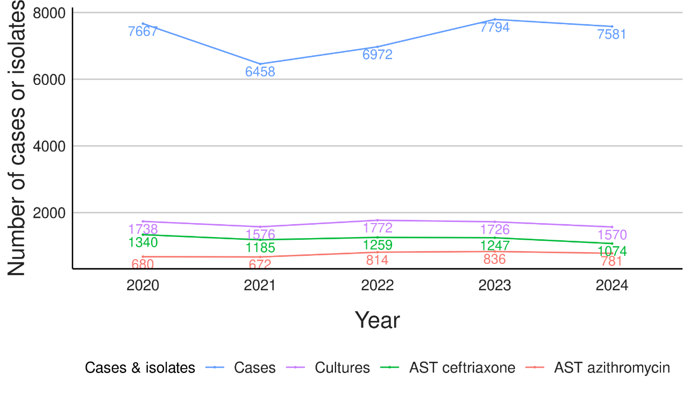
Figure 1: Number of gonorrhoea cases reported and isolates subsequently undergoing antimicrobial susceptibility testing for azithromycin and ceftriaxone in New Zealand:
2020–2024

Table 3: Total number of gonococcal infections, culture tests, positive culture results, azithromycin and ceftriaxone AST results by year: 2020–2024
Year | No. of infections | No. of culture tests (%) | No. of positive culture results (%) | No. of Azithromycin AST results (%) | No. of Ceftriaxone AST results (%)
2020 | 7,667 | 1738 (22.7%) | 1409 (81.1%) | 680 (8.9%) | 1340 (17.5%)
2021 | 6,458 | 1576 (24.4%) | 1223 (77.6%) | 672 (10.4%) | 1185 (18.3%)
2022 | 6,972 | 1772 (25.4%) | 1326 (74.8%) | 814 (11.7%) | 1259 (18.1%)
2023 | 7,794 | 1726 (22.1%) | 1288 (74.6%) | 836 (10.7%) | 1247 (16.0%)
2024 | 7,581 | 1570 (20.7%) | 1119 (71.3%) | 781 (10.3%) | 1074 (14.2%)

Azithromycin & Ceftriaxone antimicrobial resistance testing results
Between 2020 and 2024 in New Zealand there have been no isolates with resistance to ceftriaxone and very few isolates reported with decreased susceptibility to ceftriaxone, therefore further trends are difficult to identify (Table 4). Further data on ceftriaxone susceptibility by sex, age, region, ethnicity and specimen site are shown in appendix Table 5.
Table 4: Neiserria gonorrhoeae with azithromycin, MIC>1.0 mg/L and ceftriaxone susceptibility in New Zealand: 2020–2024
 | 2020 | 2021 | 2022 | 2023 | 2024
Azithromycin  (MIC >1.0 mg/L) | 62/680  (9.1%) | 36/672  (5.4%) | 12/814  (1.5%) | 27/836  (3.2%) | 20/781  (2.6%)
Ceftriaxone, decreased susceptibility  (MIC 0.06 to 0.125 mg/L) | 14/1340  (1.0%) | 14/1185  (1.2%) | 8/1259  (0.6%) | 9/1247  (0.7%) | 6/1074  (0.6%)
Ceftriaxone resistant  (MIC >0.125mg/L) | 0 | 0 | 0 | 0 | 0
The proportion of isolates with azithromycin MIC >1.0 mg/L has fluctuated between 2020 and 2024, with a peak of 9.1% in 2020, a low of 1.5% in 2022, and 2.6% in 2024. Further data on azithromycin susceptibility by sex, age, region, ethnicity and specimen site are shown in Appendix Table 6.

Penicillin resistance
The majority of AST for penicillin testing was undertaken in Te Manawa Taki and Te Waipounamu regions, with 165 and 119 isolates tested for penicillin susceptibility in these regions, respectively, in 2024. Low numbers of isolates underwent penicillin AST in the Central (23) and Northern (18) regions in 2024. Further information on penicillin susceptibility is provided in appendix Table 7.
Resistance to penicillin increased further in 2024 to 22.2%, from 16.9% in 2023 (Figure 2). The proportion of isolates with decreased susceptibility/susceptible, increased exposure to penicillin decreased concomitantly (80.1% in 2023 to 72.6% in 2024) with the increase in resistance while the proportion of fully susceptible isolates remained low (5.2%) in 2024.
By sex, the proportion of isolates with resistance to penicillin was 9.8% among females in 2024, a slight decrease from 11% in 2023. Among males, the proportion of resistant isolates increased to 25% in 2024, from 18% in 2023. By age and ethnicity, intermediate resistance to penicillin has fluctuated.
Figure 2: Proportion of N. gonorrhoeae isolates by susceptibility* to penicillin in
New Zealand: 2020–2024
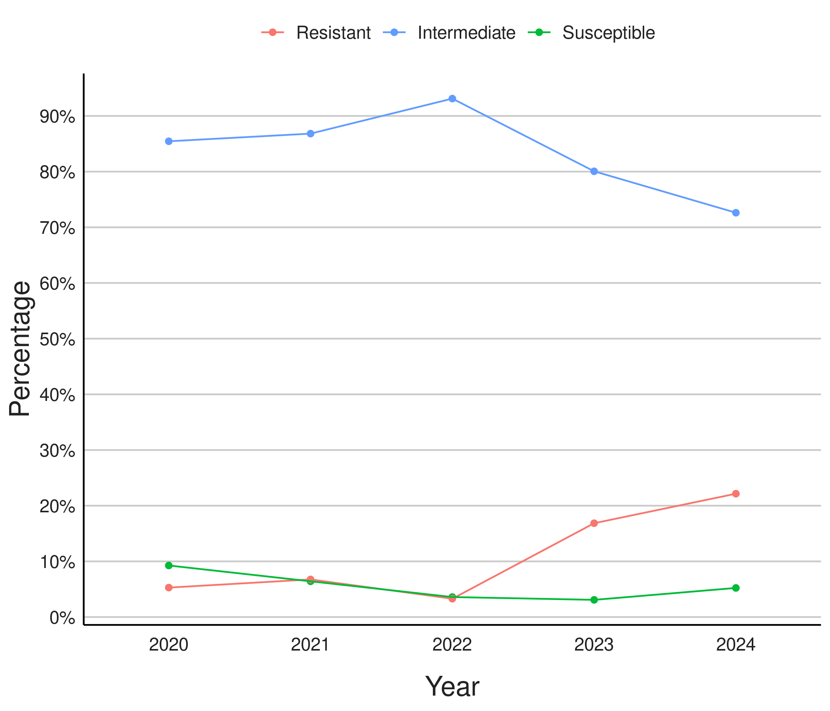
* Intermediate means decreased susceptibility/susceptible, increased exposure

Ciprofloxacin resistance
Ciprofloxacin resistance decreased in 2024 to 35%, after fluctuating between 31% and 41% in prior years (Figure 3 and appendix Table 8). Isolates categorised as susceptible, increased exposure to ciprofloxacin represent <1% (<10 isolates) of AST each year (Figure 3).
By sex, resistance to ciprofloxacin followed the overall trend among males but has decreased among females in most reporting years from 27% in 2020 to 14% in 2024.
By age, the highest proportion of resistant isolates has consistently been amongst those aged 20-39 and 40+ years. By ethnicity, across all reporting years, the highest proportion of resistant isolates (between 43–59% since 2021) were seen among isolates from people of Asian ethnicity followed by European/other ethnicities.
Figure 3: Proportion of N. gonorrhoeae isolates by susceptibility* to ciprofloxacin in New Zealand: 2020–2024
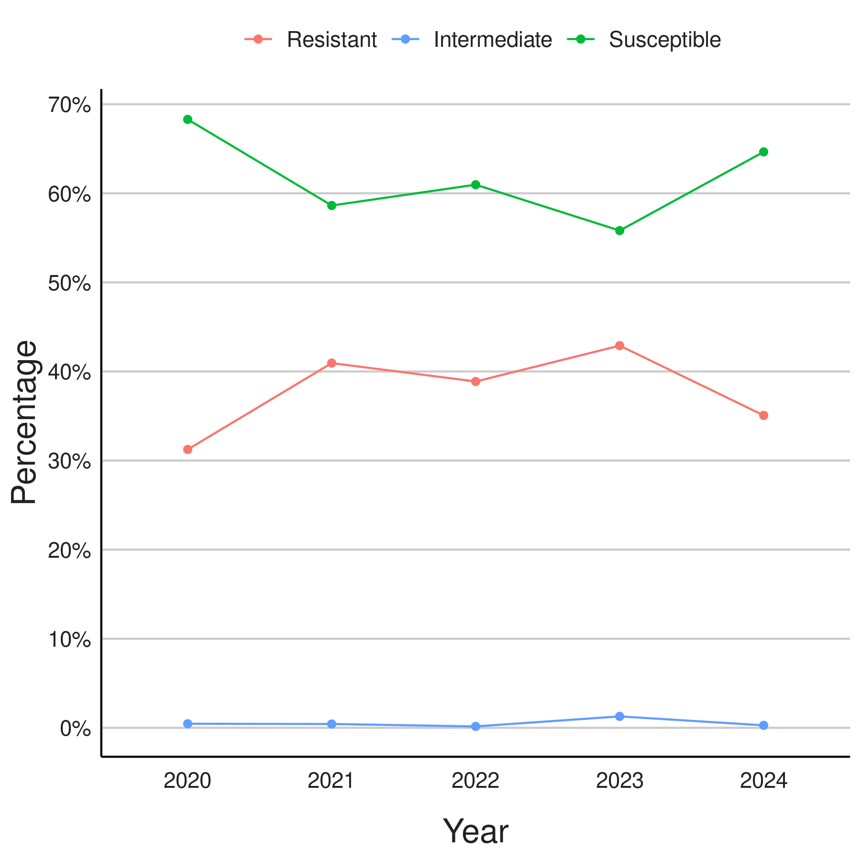
* Intermediate means susceptible, increased exposure

Tetracycline resistance
As in most previous years, tetracycline AST results for 2024 were received from only one laboratory (Southern | Te Waipounamu). The number of isolates with AST for tetracycline reported decreased in 2024 to 99 from 164 in 2023 (Appendix Table 9). Tetracycline resistance increased in 2024 compared to 2023 and 2022 (44.4% from 31.1% and 15.3%) (Figure 4). The clinical breakpoints for tetracycline and N. gonorrhoeae changed in 2023, although, as the majority of results received were interpreted results (SIR instead of MIC or ZD data), the impact of the new breakpoints is unclear. Although the number of resistant isolates is highest amongst males each year, the proportion of resistant isolates by sex fluctuates for each reporting year. Given low isolate numbers, there are no trends by age and ethnicity to report.
Figure 4: Proportion of N. gonorrhoeae isolates by susceptibility* to tetracycline in New Zealand: 2020–2024
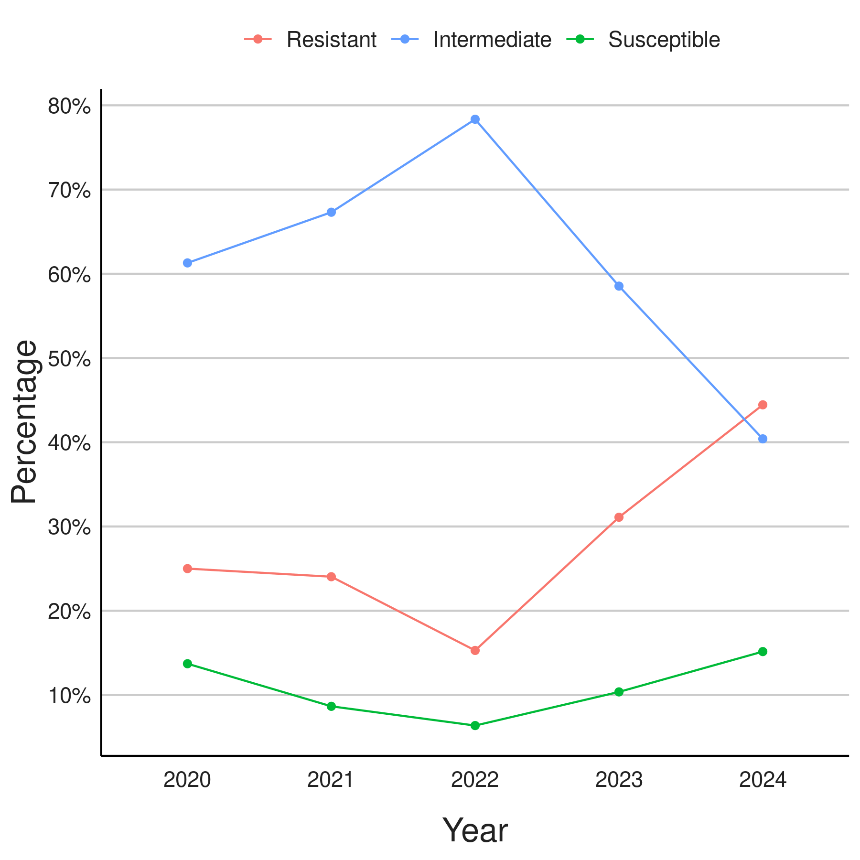
* Intermediate means decreased susceptibility/susceptible, increased exposure

Discussion
To date there have been no reported ceftriaxone-resistant gonococcal isolates in New Zealand, and the number of isolates with decreased susceptibility to ceftriaxone (MIC≥0.06 mg/L) remains low, at 0.6% in 2024. Almost all gonococci (96%) with a positive culture underwent AST for ceftriaxone in 2024. Further descriptive analysis of cases with decreased susceptibility to ceftriaxone is limited due to the low numbers (see appendix Table 5).
The proportion of isolates with azithromycin MIC above the ECOFF (>1.0 mg/L) has fluctuated over time, decreasing from 2020 to 2022 and fluctuating since. The highest MIC reported to-date is 32 mg/L in 2023, with an additional four isolates reported with an MIC of 16 mg/L in 2020 (n=1), 2022 (n=1) and 2023 (n=2). The highest reported MIC in 2024 was 4 mg/L.
For comparison, in Australia, in quarters 1-3 2024, 0.31% to 0.73% of N. gonorrhoeae in each quarter were ceftriaxone-resistant with MIC values ≥0.125 mg/L (9/2920, 21/2859 and 10/2628 by quarter) compared to 0.22% in 2023 (14). The AGSP reports isolates with an MIC of ≥0.06 mg/L as decreased susceptibility to ceftriaxone; with 1.67-2.88% of isolates with this profile in quarters 1-3 2024, compared to 3.29% in 2023 (14).
In 2024 quarters 1-3, Australia reported 3.3-5.7% of isolates tested each quarter as resistant (MIC >1.0 mg/L) to azithromycin compared to 4.5% in 2023 with 40 isolates exhibiting high-level resistance (MIC ≥ 256mg/L) (14). During this time there were also 5 extensively drug-resistant isolates reported, with both resistance to ceftriaxone and high-level azithromycin resistance.
Continued vigilance is required to detect and monitor ceftriaxone resistance in New Zealand and maintain the effectiveness of current available gonorrhoea treatment. This is particularly important in the context of the increasing N. gonorrhoeae antimicrobial resistance globally, including our closest neighbours, Australia (19).
Monitoring resistance to tetracycline may become more relevant with the increasing use of doxycycline post-exposure prophylaxis (doxy-PEP), as an STI prevention strategy, particularly for men who have sex with men (19). Although this report shows an increase in resistance to tetracycline in 2023-2024, it is unknown whether this data is representative of tetracycline resistance rates across New Zealand since only one laboratory currently tests N. gonorrhoeae against tetracycline. More laboratories would need to introduce tetracycline AST if more comprehensive and representative tetracycline susceptibility data were required.
In 2024, culture was undertaken for 21% of gonococcal infections, a slight decrease from over 25% in 2022 with an overall proportion of all infections providing a positive culture for AST decreasing 19% to 14.8% in 2024. While this is comparable to the proportion of gonorrhoea cases with isolates available for AST in some countries, for example Canada where around 10% of cases undergo AST, it is lower than reported in Australia in 2023 (25%) (20, 21). Comparisons with UK and US AMR surveillance is difficult due to differences in the sentinel surveillance systems in use (22, 23)

New Zealand N. gonorrhoeae AMR data are not systematically sampled and are influenced by swabbing practices. Cultures are primarily taken in sexual health services, with sampling bias potentially affecting generalisability of resistance profiles. An improved understanding of the demographics of those swabbed, including through the integration of clinical and laboratory data, may provide insight. To fully understand site of infection, sexual behaviour is an important consideration, however this is not collected with laboratory data and laboratory results cannot currently be routinely linked with clinical notifications.
There are a number of known challenges with the quality of New Zealand’s N. gonorrhoeae AMR data that persist, including variation in laboratory testing protocols, the small numbers of isolates tested, and the potential for transcription errors during the manual process of data referral to PHF Science. Introducing consistency in testing between laboratories and implementing an automated data repository would help improve the reliability of the data.
Effective surveillance of N. gonorrhoeae AMR is crucial for the early detection of resistant strains and to ensure treatment guidelines are appropriate. Continued efforts to increase the proportion of cases for which isolates are referred for culture from clinicians and which are tested for susceptibility to important antimicrobials across all regions are recommended. Specific areas to increase testing include azithromycin AST in the Central region, and tetracycline AST beyond the Canterbury region.
With the universal use of NAAT for gonorrhoea diagnosis, it would be timely to explore alternative culture-independent methods of N. gonorrhoeae surveillance. Although not yet in routine use internationally for national surveillance, research efforts into culture-independent detection of N. gonorrhoeae antimicrobial resistance determinants, as well as phylogenetic relationships, using molecular and sequencing techniques, are ongoing, and likely to be an area of rapid future development (24-27).

REFERENCES

1. World Health Organisation. Multi-drug resistant gonorrhoea 2024 [Available from: https://www.who.int/news-room/fact-sheets/detail/multi-drug-resistant-gonorrhoea.
2. Moore MS, Golden MR, Scholes D, Kerani RP. Assessing Trends in Chlamydia Positivity and Gonorrhea Incidence and Their Associations With the Incidence of Pelvic Inflammatory Disease and Ectopic Pregnancy in Washington State, 1988-2010. Sex Transm Dis. 2016;43(1):2-8.
3. Tsevat DG, Wiesenfeld HC, Parks C, Peipert JF. Sexually transmitted diseases and infertility. Am J Obstet Gynecol. 2017;216(1):1-9.
4. World Health Organisation. WHO bacterial priority pathogens list, 2024: Bacterial pathogens of public health importance to guide research, development and strategies to prevent and control antimicrobial resistance. 2024.
5. Unemo M, Lahra MM, Cole M, Galarza P, Ndowa F, Martin I, et al. World Health Organization Global Gonococcal Antimicrobial Surveillance Program (WHO GASP): review of new data and evidence to inform international collaborative actions and research efforts. Sex Health. 2019;16(5):412-25.
6. Unemo M, Lahra MM, Escher M, Eremin S, Cole MJ, Galarza P, et al. WHO global antimicrobial resistance surveillance for Neisseria gonorrhoeae 2017-18: a retrospective observational study. Lancet Microbe. 2021;2(11):e627-e36.
7. New Zealand Sexual Health Society. Gonorrhoea: Management and Guidelines [Available from: https://sti.guidelines.org.nz/infections/gonorrhoea/.
8. Australian Society for HIV VHaSHM. Australian STI Management Guidelines for use in primary care. 2024.
9. Fifer H, Ismail MA, Soni S, Nwaosu U, Sadiq ST, Milligan A, et al. British Association of Sexual Health and HIV UK National Guideline for the Management of infection with Neisseria gonorrhoeae, 2025. Int J STD AIDS. 2025:9564624251345195.
10. St Cyr S, Barbee L, Workowski KA, Bachmann LH, Pham C, Schlanger K, et al. Update to CDC's Treatment Guidelines for Gonococcal Infection, 2020. MMWR Morb Mortal Wkly Rep. 2020;69(50):1911-6.
11. Government of Canada. Gonorrhea guide: Treatment and follow-up 2025 [Available from: https://www.canada.ca/en/public-health/services/infectious-diseases/sexual-health-sexually-transmitted-infections/canadian-guidelines/gonorrhea/treatment-follow-up.html.
12. Ouk V, Pham CD, Wi T, van Hal SJ, Lahra MM. The Enhanced Gonococcal Surveillance Programme, Cambodia. Lancet Infect Dis. 2023;23(9):e332-e3.
13. Zhu X, Xi Y, Gong X, Chen S. Ceftriaxone-Resistant Gonorrhea - China, 2022. MMWR Morb Mortal Wkly Rep. 2024;73(12):255-9.
14. Lahra MM, van Hal S, Hutabarat SN, Hogan TR. Australian Gonococcal Surveillance Program, 1 April to 30 June 2024. Commun Dis Intell (2018). 2025;49.
15. The Institute of Environmental Science and Research Ltd. Sexually Transmitted Infections in New Zealand Annual Surveillance Report. 2019.
16. The Institue of Environmental Science and Research Ltd. Antimicrobial resistance in Neisseria gonorrhoea in New Zealand 2022 Surveillance Report. 2023.
17. Antimicrobial resistance in Neisseria gonorrhoea in New Zealand 2022 Surveillance Report. 2021.
18. The Instititute of Environmental Science and Research Ltd. Sexually Transmitted Infections in New Zealand: Supplementary Annual Surveillance Report 2023. 2024.
19. New South Wales Health. Antimirobial Resistant Gonorrhoea 2024 [Available from: https://www.health.nsw.gov.au/Infectious/alerts/Documents/2024/AMR-gonorrhoea-GP-ALERT-20240613.pdf.
20. Lahra MM, van Hal S, Hogan TR. Australian Gonococcal Surveillance Programme, 1 October to 31 December 2023. Commun Dis Intell (2018). 2024;48.
21. Sawatzky P, Thorington R, Barairo N, Lefebvre B, Diggle M, Hoang L, et al. Antimicrobial susceptibilities of Neisseria gonorrhoeae in Canada, 2022. Can Commun Dis Rep. 2025;51(4):129-36.
22. UK Health Security Agency. Antimicrobial resistance in Neisseria gonorrhoeae in England and Wales: Key findings from the Gonococcal Resistance to Antimicrobials Surveillance Programme (GRASP 2021). 2022.
23. Centers for Disease Control and Prevention. Sexually Transmitted Disease Surveillance 2022: Gonococcal Isolate Surveillance Project Profile 2024 [Available from: https://www.cdc.gov/sti-statistics/media/pdfs/2024/07/2022-GISP-Profiles_National_CLEARED_CLEAN.pdf.
24. Donà V, Kasraian S, Lupo A, Guilarte YN, Hauser C, Furrer H, et al. Multiplex Real-Time PCR Assay with High-Resolution Melting Analysis for Characterization of Antimicrobial Resistance in Neisseria gonorrhoeae. J Clin Microbiol. 2016;54(8):2074-81.
25. Sati H, Carrara E, Savoldi A, Hansen P, Garlasco J, Campagnaro E, et al. The WHO Bacterial Priority Pathogens List 2024: a prioritisation study to guide research, development, and public health strategies against antimicrobial resistance. Lancet Infect Dis. 2025.
26. Slaats MHC, van der Veer B, van Alphen LB, Hoebe C, Dukers-Muijrers N, Wolffs PFG. Culture-Independent Genotyping Improves Surveillance of Neisseria gonorrhoeae, Especially in Oropharyngeal Samples, the Netherlands, 2017 to 2018. Pathogens. 2022;11(11).
27. Street TL, Sanderson ND, Barker L, Kavanagh J, Cole K, The GonFast Investigators G, et al. Target enrichment improves culture-independent detection of Neisseria gonorrhoeae and antimicrobial resistance determinants direct from clinical samples with Nanopore sequencing. Microb Genom. 2024;10(3).

Appendices
Table 5: Number & proportion (%) of gonococcal isolates by susceptibility to ceftriaxone*, New Zealand, 2020–2024 by sex, age, ethnicity, region, and specimen site
Sex | 2020 |  | 2021 |  | 2022 |  | 2023 |  | 2024
Sex | S  N = 1,326¹ | DS  N = 14¹ | S  N = 1,171¹ | DS  N = 14¹ | S  N = 1,251¹ | DS  N = 8¹ | S  N = 1,238¹ | DS  N = 9¹ | S  N = 1,068¹ | DS  N = 6¹
Female | 304 (97%) | 8 (2.6%) | 196 (97%) | 6 (3.0%) | 224 (98%) | 4 (1.8%) | 190 (99%) | 2 (1.0%) | 146 (99%) | 1 (0.7%)
Male | 1,022 (99%) | 6 (0.6%) | 975 (99%) | 8 (0.8%) | 1,027 (100%) | 4 (0.4%) | 1,048 (99%) | 7 (0.7%) | 922 (99%) | 5 (0.5%)
Age group
0–14 | 10 (100%) | - | 8 (100%) | - | - | - | - | - | 3 (100%) | -
15–19 | 103 (99%) | 1 (1.0%) | 99 (100%) | - | 102 (100%) | - | 113 (100%) | - | 91 (100%) | -
20–24 | 291 (99%) | 3 (1.0%) | 223 (98%) | 4 (1.8%) | 303 (99%) | 3 (1.0%) | 269 (100%) | - | 234 (100%) | 1 (0.4%)
25–29 | 314 (98%) | 5 (1.6%) | 271 (99%) | 2 (0.7%) | 273 (100%) | 1 (0.4%) | 272 (99%) | 3 (1.1%) | 220 (99%) | 2 (0.9%)
30–39 | 371 (100%) | 1 (0.3%) | 359 (99%) | 4 (1.1%) | 345 (99%) | 3 (0.9%) | 337 (99%) | 5 (1.5%) | 321 (100%) | 1 (0.3%)
40+ | 237 (98%) | 4 (1.7%) | 211 (98%) | 4 (1.9%) | 228 (100%) | 1 (0.4%) | 247 (100%) | 1 (0.4%) | 199 (99%) | 2 (1.0%)
Ethnicity
Asian | 112 (99%) | 1 (0.9%) | 120 (98%) | 2 (1.6%) | 118 (99%) | 1 (0.8%) | 140 (99%) | 2 (1.4%) | 153 (100%) | -
European/Other | 489 (100%) | 2 (0.4%) | 447 (100%) | 2 (0.4%) | 508 (100%) | 2 (0.4%) | 498 (100%) | - | 394 (100%) | 1 (0.3%)
Māori | 326 (98%) | 5 (1.5%) | 299 (98%) | 5 (1.6%) | 331 (100%) | 1 (0.3%) | 276 (100%) | - | 317 (99%) | 3 (0.9%)
Pacific | 186 (100%) | - | 167 (99%) | 1 (0.6%) | 197 (99%) | 2 (1.0%) | 184 (100%) | - | 149 (100%) | -
Unknown | 213 (97%) | 6 (2.7%) | 138 (97%) | 4 (2.8%) | 97 (98%) | 2 (2.0%) | 140 (95%) | 7 (4.8%) | 55 (96%) | 2 (3.5%)
Region
Central | 146 (99%) | 2 (1.4%) | 105 (99%) | 1 (0.9%) | 99 (100%) | - | 108 (100%) | - | 96 (100%) | -
Northern | 626 (100%) | 3 (0.5%) | 573 (99%) | 6 (1.0%) | 561 (99%) | 4 (0.7%) | 606 (100%) | 1 (0.2%) | 568 (100%) | -
Te Manawa Taki | 276 (97%) | 9 (3.2%) | 266 (97%) | 7 (2.6%) | 299 (99%) | 4 (1.3%) | 283 (98%) | 7 (2.4%) | 269 (98%) | 5 (1.8%)
Te Waipounamu | 278 (100%) | - | 227 (100%) | - | 292 (100%) | - | 241 (100%) | 1 (0.4%) | 135 (99%) | 1 (0.7%)
Specimen Site
Ano-rectal | 118 (100%) | - | 141 (99%) | 1 (0.7%) | 134 (100%) | - | 166 (100%) | - | 176 (99%) | 1 (0.6%)
Other/Unknown | 66 (100%) | - | 45 (96%) | 2 (4.3%) | 45 (100%) | - | 36 (100%) | - | 28 (100%) | -
Pharyngeal | 33 (100%) | - | 48 (96%) | 2 (4.0%) | 64 (98%) | 1 (1.5%) | 88 (98%) | 2 (2.2%) | 86 (99%) | 1 (1.1%)
Urogenital | 1,109 (99%) | 14 (1.2%) | 937 (99%) | 9 (1.0%) | 1,008 (99%) | 7 (0.7%) | 948 (99%) | 7 (0.7%) | 778 (99%) | 4 (0.5%)
¹N (row % per year, rounding to 1 decimal place if low counts) * No Resistant isolates (MIC >0.125 mg/L) reported
DS = Decreased Susceptibility (MIC 0.06 to 0.125mg/L). Not a clinically important MIC breakpoint; reported for surveillance purposes only
Table 6: Number & proportion (%) of gonococcal isolates with azithromycin MIC >1.0 mg/L*, New Zealand, 2020-2024 by sex, age, ethnicity and region
Sex | 2020 |  | 2021 |  | 2022 |  | 2023 |  | 2024
Sex | S  N = 618¹ | MIC >1²  N = 62¹ | S  N = 636¹ | MIC >1²  N = 36¹ | S  N = 802¹ | MIC >1²  N = 12¹ | S  N = 809¹ | MIC >1²  N = 27¹ | S  N = 761¹ | MIC >1²  N = 20¹
Female | 127 (95%) | 6 (4.5%) | 109 (97%) | 3 (2.7%) | 146 (98%) | 3 (2.0%) | 131 (98%) | 3 (2.2%) | 112 (95%) | 6 (5.1%)
Male | 491 (90%) | 56 (10%) | 527 (94%) | 33 (5.9%) | 656 (99%) | 9 (1.4%) | 678 (97%) | 24 (3.4%) | 649 (98%) | 14 (2.1%)
Age group
0–14 | 1 (100%) | - | 4 (100%) | - | - | - | - | - | 2 (100%) | -
15–19 | 42 (95%) | 2 (4.5%) | 44 (94%) | 3 (6.4%) | 58 (100%) | - | 61 (94%) | 4 (6.2%) | 51 (91%) | 5 (8.9%)
20–24 | 134 (93%) | 10 (6.9%) | 104 (95%) | 6 (5.5%) | 200 (99%) | 3 (1.5%) | 160 (97%) | 5 (3.0%) | 167 (97%) | 5 (2.9%)
25–29 | 156 (92%) | 13 (7.7%) | 157 (97%) | 5 (3.1%) | 157 (98%) | 3 (1.9%) | 185 (96%) | 8 (4.1%) | 162 (98%) | 3 (1.8%)
30–39 | 180 (90%) | 20 (10%) | 200 (94%) | 12 (5.7%) | 244 (99%) | 2 (0.8%) | 228 (97%) | 6 (2.6%) | 229 (98%) | 4 (1.7%)
40+ | 105 (86%) | 17 (14%) | 127 (93%) | 10 (7.3%) | 143 (97%) | 4 (2.7%) | 175 (98%) | 4 (2.2%) | 150 (98%) | 3 (2.0%)
Ethnicity
Asian | 57 (95%) | 3 (5.0%) | 71 (96%) | 3 (4.1%) | 73 (99%) | 1 (1.4%) | 107 (99%) | 1 (0.9%) | 112 (100%) | -
European/Other | 184 (85%) | 32 (15%) | 230 (93%) | 17 (6.9%) | 307 (98%) | 6 (1.9%) | 309 (97%) | 10 (3.1%) | 285 (95%) | 14 (4.7%)
Māori | 138 (91%) | 13 (8.6%) | 162 (95%) | 8 (4.7%) | 216 (99%) | 3 (1.4%) | 165 (97%) | 5 (2.9%) | 219 (98%) | 4 (1.8%)
Pacific | 74 (96%) | 3 (3.9%) | 77 (97%) | 2 (2.5%) | 117 (99%) | 1 (0.8%) | 98 (97%) | 3 (3.0%) | 101 (100%) | -
Unknown | 165 (94%) | 11 (6.3%) | 96 (94%) | 6 (5.9%) | 89 (99%) | 1 (1.1%) | 130 (94%) | 8 (5.8%) | 44 (96%) | 2 (4.3%)
Region
Central | - | 1 (100%) | 1 (100%) | - | - | - | - | - | 4 (100%) | -
Northern | 310 (95%) | 17 (5.2%) | 318 (93%) | 24 (7.0%) | 367 (99%) | 3 (0.8%) | 416 (98%) | 8 (1.9%) | 434 (98%) | 10 (2.3%)
Te Manawa Taki | 217 (95%) | 11 (4.8%) | 218 (97%) | 7 (3.1%) | 284 (98%) | 5 (1.7%) | 232 (93%) | 18 (7.2%) | 230 (98%) | 4 (1.7%)
Te Waipounamu | 91 (73%) | 33 (27%) | 99 (95%) | 5 (4.8%) | 151 (97%) | 4 (2.6%) | 161 (99%) | 1 (0.6%) | 93 (94%) | 6 (6.1%)
Specimen Site
Ano-rectal | 89 (83%) | 18 (17%) | 121 (93%) | 9 (6.9%) | 123 (97%) | 4 (3.1%) | 163 (100%) | - | 163 (98%) | 4 (2.4%)
Other/Unknown | 8 (89%) | 1 (11%) | 15 (94%) | 1 (6.3%) | 7 (100%) | - | 12 (92%) | 1 (7.7%) | 9 (90%) | 1 (10%)
Pharyngeal | 24 (75%) | 8 (25%) | 41 (87%) | 6 (13%) | 64 (98%) | 1 (1.5%) | 86 (97%) | 3 (3.4%) | 81 (95%) | 4 (4.7%)
Urogenital | 497 (93%) | 35 (6.6%) | 459 (96%) | 20 (4.2%) | 608 (99%) | 7 (1.1%) | 548 (96%) | 23 (4.0%) | 508 (98%) | 11 (2.1%)
¹ Susceptible isolates MIC <1mg/L
² MIC>1 denotes isolates with MIC >1mg/L* No isolates with high-level resistance (MIC >256mg/L) reported in NZ
³ N (row % per year, rounding to 1 decimal place if low counts)
Table 7: Number & proportion (%) of gonococcal isolates by susceptibility to penicillin, New Zealand, 2020–2024 by sex, age, ethnicity and region
Sex | 2020 |  |  | 2021 |  |  | 2022 |  |  | 2023 |  |  | 2024
Sex | S  N = 35¹ | I  N = 323¹ | R  N = 20¹ | S  N = 19¹ | I  N = 257¹ | R  N = 20¹ | S  N = 12¹ | I  N = 311¹ | R  N = 11¹ | S  N = 11¹ | I  N = 285¹ | R  N = 60¹ | S  N = 17¹ | I  N = 236¹ | R  N = 72¹
Female | 13 (14%) | 74 (80%) | 5 (5.4%) | 4 (8.3%) | 43 (90%) | 1 (2.1%) | - | 67 (99%) | 1 (1.5%) | 2 (3.1%) | 56 (86%) | 7 (11%) | 5 (8.2%) | 50 (82%) | 6 (9.8%)
Male | 22 (7.7%) | 249 (87%) | 15 (5.2%) | 15 (6.0%) | 214 (86%) | 19 (7.7%) | 12 (4.5%) | 244 (92%) | 10 (3.8%) | 9 (3.1%) | 229 (79%) | 53 (18%) | 12 (4.5%) | 186 (70%) | 66 (25%)
Age group
0–14 | 1 (33%) | 2 (67%) | - | - | 1 (100%) | - | - | - | - | - | - | - | - | - | 1 (100%)
15–19 | 3 (13%) | 18 (78%) | 2 (8.7%) | 1 (6.3%) | 15 (94%) | - | 1 (4.3%) | 22 (96%) | - | 2 (6.5%) | 24 (77%) | 5 (16%) | 3 (9.7%) | 22 (71%) | 6 (19%)
20–24 | 12 (14%) | 70 (82%) | 3 (3.5%) | 1 (2.2%) | 42 (91%) | 3 (6.5%) | 4 (5.2%) | 71 (92%) | 2 (2.6%) | 3 (4.1%) | 59 (80%) | 12 (16%) | 4 (5.1%) | 57 (73%) | 17 (22%)
25–29 | 5 (6.7%) | 63 (84%) | 7 (9.3%) | 6 (9.5%) | 53 (84%) | 4 (6.3%) | 1 (1.6%) | 59 (94%) | 3 (4.8%) | 4 (5.7%) | 55 (79%) | 11 (16%) | 3 (4.8%) | 49 (79%) | 10 (16%)
30–39 | 8 (6.7%) | 106 (89%) | 5 (4.2%) | 8 (8.2%) | 79 (81%) | 10 (10%) | 5 (5.1%) | 91 (93%) | 2 (2.0%) | 2 (2.2%) | 71 (80%) | 16 (18%) | 5 (5.4%) | 64 (69%) | 24 (26%)
40+ | 6 (8.2%) | 64 (88%) | 3 (4.1%) | 3 (4.1%) | 67 (92%) | 3 (4.1%) | 1 (1.4%) | 68 (93%) | 4 (5.5%) | - | 76 (83%) | 16 (17%) | 2 (3.3%) | 44 (73%) | 14 (23%)
Ethnicity
Asian | 1 (9.1%) | 9 (82%) | 1 (9.1%) | 1 (8.3%) | 8 (67%) | 3 (25%) | - | 13 (100%) | - | - | 23 (74%) | 8 (26%) | - | 22 (79%) | 6 (21%)
European/Other | 12 (9.3%) | 112 (87%) | 5 (3.9%) | 3 (2.7%) | 98 (89%) | 9 (8.2%) | 5 (3.0%) | 156 (95%) | 4 (2.4%) | 4 (2.7%) | 117 (78%) | 29 (19%) | 3 (2.2%) | 91 (67%) | 42 (31%)
Māori | 6 (6.7%) | 80 (89%) | 4 (4.4%) | 7 (8.5%) | 70 (85%) | 5 (6.1%) | 6 (4.9%) | 113 (92%) | 4 (3.3%) | 4 (4.2%) | 83 (87%) | 8 (8.4%) | 14 (10%) | 108 (78%) | 17 (12%)
Pacific | - | 14 (82%) | 3 (18%) | 3 (20%) | 11 (73%) | 1 (6.7%) | - | 10 (91%) | 1 (9.1%) | 2 (12%) | 11 (65%) | 4 (24%) | - | 10 (77%) | 3 (23%)
Unknown | 16 (12%) | 108 (82%) | 7 (5.3%) | 5 (6.5%) | 70 (91%) | 2 (2.6%) | 1 (4.5%) | 19 (86%) | 2 (9.1%) | 1 (1.6%) | 51 (81%) | 11 (17%) | - | 5 (56%) | 4 (44%)
Region
Central | 9 (14%) | 52 (80%) | 4 (6.2%) | 4 (29%) | 10 (71%) | - | 1 (17%) | 4 (67%) | 1 (17%) | 2 (18%) | 8 (73%) | 1 (9.1%) | 4 (17%) | 15 (65%) | 4 (17%)
Northern | 2 (14%) | 10 (71%) | 2 (14%) | 6 (33%) | 12 (67%) | - | - | 4 (100%) | - | 1 (11%) | 7 (78%) | 1 (11%) | 1 (5.6%) | 17 (94%) | -
Te Manawa Taki | 19 (13%) | 119 (83%) | 6 (4.2%) | 9 (6.1%) | 134 (91%) | 4 (2.7%) | 11 (6.8%) | 148 (91%) | 3 (1.9%) | 7 (4.5%) | 134 (87%) | 13 (8.4%) | 11 (6.7%) | 137 (83%) | 17 (10%)
Te Waipounamu | 5 (3.2%) | 142 (92%) | 8 (5.2%) | - | 101 (86%) | 16 (14%) | - | 155 (96%) | 7 (4.3%) | 1 (0.5%) | 136 (75%) | 45 (25%) | 1 (0.8%) | 67 (56%) | 51 (43%)
¹N (row % per year, rounding to 1 decimal place if low counts)
Table 8: Number & proportion (%) of gonococcal isolates susceptible or resistance to ciprofloxacin, New Zealand, 2020–2024 by sex, age, ethnicity and region
 | 2020 |  |  | 2021 |  |  | 2022 |  |  | 2023 |  |  |  | 2024
Sex | S  N = 894¹ | I  N = 6¹ | R  N = 409¹ | S  N = 686¹ | I  N = 5¹ | R  N = 479¹ | S  N = 770¹ | I  N = 2¹ | R  N = 491¹ | S  N = 696¹ | I  N = 16¹ | R  N = 535¹ | S  N = 695¹ |  | I  N = 3¹ | R  N = 377¹
Female | 215 (73%) | - | 80 (27%) | 156 (80%) | 1 (0.5%) | 38 (19%) | 184 (81%) | - | 44 (19%) | 151 (79%) | 4 (2.1%) | 37 (19%) | 127 (86%) |  | - | 20 (14%)
Male | 679 (67%) | 6 (0.6%) | 329 (32%) | 530 (54%) | 4 (0.4%) | 441 (45%) | 586 (57%) | 2 (0.2%) | 447 (43%) | 545 (52%) | 12 (1.1%) | 498 (47%) | 568 (61%) |  | 3 (0.3%) | 357 (38%)
Age group
0–14 | 9 (82%) | - | 2 (18%) | 7 (100%) | - | - | - | - | - | - | - | - | 3 (100%) |  | - | -
15–19 | 76 (77%) | 1 (1.0%) | 22 (22%) | 78 (80%) | 1 (1.0%) | 18 (19%) | 67 (65%) | - | 36 (35%) | 89 (79%) | - | 24 (21%) | 73 (80%) |  | - | 18 (20%)
20–24 | 223 (77%) | 2 (0.7%) | 65 (22%) | 153 (68%) | 3 (1.3%) | 68 (30%) | 206 (67%) | - | 102 (33%) | 168 (62%) | 6 (2.2%) | 95 (35%) | 171 (73%) |  | - | 64 (27%)
25–29 | 214 (68%) | 1 (0.3%) | 98 (31%) | 153 (56%) | - | 119 (44%) | 180 (65%) | 1 (0.4%) | 94 (34%) | 153 (56%) | 3 (1.1%) | 119 (43%) | 148 (66%) |  | 2 (0.9%) | 73 (33%)
30–39 | 212 (60%) | 2 (0.6%) | 142 (40%) | 197 (55%) | 1 (0.3%) | 162 (45%) | 187 (54%) | 1 (0.3%) | 160 (46%) | 170 (50%) | 6 (1.8%) | 166 (49%) | 182 (57%) |  | - | 140 (43%)
40+ | 160 (67%) | - | 80 (33%) | 98 (47%) | - | 112 (53%) | 130 (57%) | - | 99 (43%) | 116 (47%) | 1 (0.4%) | 131 (53%) | 118 (59%) |  | 1 (0.5%) | 82 (41%)
Ethnicity
Asian | 74 (66%) | 1 (0.9%) | 37 (33%) | 49 (41%) | - | 71 (59%) | 50 (42%) | - | 69 (58%) | 61 (43%) | 1 (0.7%) | 80 (56%) | 82 (53%) |  | - | 72 (47%)
European/ Other | 278 (58%) | 3 (0.6%) | 196 (41%) | 226 (51%) | 2 (0.5%) | 214 (48%) | 271 (53%) | 1 (0.2%) | 241 (47%) | 239 (48%) | 7 (1.4%) | 252 (51%) | 221 (56%) |  | 1 (0.3%) | 173 (44%)
Māori | 233 (73%) | 1 (0.3%) | 87 (27%) | 208 (70%) | 2 (0.7%) | 89 (30%) | 220 (66%) | 1 (0.3%) | 111 (33%) | 177 (64%) | 3 (1.1%) | 96 (35%) | 240 (75%) |  | - | 80 (25%)
Pacific | 156 (86%) | 1 (0.5%) | 25 (14%) | 111 (66%) | 1 (0.6%) | 55 (33%) | 150 (75%) | - | 49 (25%) | 122 (66%) | 1 (0.5%) | 61 (33%) | 111 (74%) |  | 1 (0.7%) | 37 (25%)
Unknown | 153 (71%) | - | 64 (29%) | 92 (65%) | - | 50 (35%) | 79 (79%) | - | 21 (21%) | 97 (66%) | 4 (2.7%) | 46 (31%) | 41 (72%) |  | 1 (1.8%) | 15 (26%)
Region
Central | 116 (78%) | - | 33 (22%) | 59 (58%) | - | 43 (42%) | 43 (43%) | 1 (1.0%) | 56 (56%) | 50 (46%) | - | 58 (54%) | 63 (66%) |  | - | 33 (34%)
Northern | 435 (70%) | 4 (0.6%) | 184 (30%) | 288 (50%) | 3 (0.5%) | 285 (49%) | 298 (53%) | - | 267 (47%) | 334 (55%) | - | 273 (45%) | 368 (65%) |  | - | 201 (35%)
Te Manawa Taki | 204 (73%) | - | 74 (27%) | 192 (71%) | - | 80 (29%) | 230 (75%) | 1 (0.3%) | 75 (25%) | 209 (72%) | 5 (1.7%) | 76 (26%) | 214 (78%) |  | 3 (1.1%) | 57 (21%)
Te Waipounamu | 139 (54%) | 2 (0.8%) | 118 (46%) | 147 (67%) | 2 (0.9%) | 71 (32%) | 199 (68%) | - | 93 (32%) | 103 (43%) | 11 (4.5%) | 128 (53%) | 50 (37%) |  | - | 86 (63%)
¹N (row % per year, rounding to 1 decimal place if low counts)
Table 9: Number & proportion (%) of gonococcal isolates by susceptibility to tetracycline, New Zealand, 2020–2024 by sex, age, ethnicity and region
Sex | 2020 |  |  | 2021 |  |  | 2022 |  |  | 2023 |  |  | 2024
Sex | S N = 17¹ | I N = 76¹ | R N = 31¹ | S N = 9¹ | I N = 70¹ | R N = 25¹ | S N = 10¹ | I N = 123¹ | R N = 24¹ | S N = 17¹ | I N = 96¹ | R N = 51¹ | S N = 15¹ | I N = 40¹ | R N = 44¹
Female | 2 (8.0%) | 15 (60%) | 8 (32%) | - | 10 (91%) | 1 (9.1%) | 1 (4.2%) | 20 (83%) | 3 (13%) | 2 (7.4%) | 16 (59%) | 9 (33%) | 3 (25%) | 5 (42%) | 4 (33%)
Male | 15 (15%) | 61 (62%) | 23 (23%) | 9 (9.7%) | 60 (65%) | 24 (26%) | 9 (6.8%) | 103 (77%) | 21 (16%) | 15 (11%) | 80 (58%) | 42 (31%) | 12 (14%) | 35 (40%) | 40 (46%)
Age group
0–14 | - | - | - | - | - | - | - | - | - | - | - | - | - | - | 1 (100%)
15–19 | - | 3 (60%) | 2 (40%) | - | 4 (100%) | - | - | 5 (71%) | 2 (29%) | - | 6 (75%) | 2 (25%) | 1 (14%) | 4 (57%) | 2 (29%)
20–24 | 5 (23%) | 11 (50%) | 6 (27%) | 2 (15%) | 6 (46%) | 5 (38%) | 4 (11%) | 29 (81%) | 3 (8.3%) | 3 (9.7%) | 20 (65%) | 8 (26%) | 7 (28%) | 9 (36%) | 9 (36%)
25–29 | 2 (8.3%) | 16 (67%) | 6 (25%) | 2 (14%) | 7 (50%) | 5 (36%) | 1 (3.0%) | 28 (85%) | 4 (12%) | 3 (8.8%) | 18 (53%) | 13 (38%) | 2 (17%) | 4 (33%) | 6 (50%)
30–39 | 6 (14%) | 28 (65%) | 9 (21%) | 3 (7.9%) | 27 (71%) | 8 (21%) | 2 (4.5%) | 33 (75%) | 9 (20%) | 5 (11%) | 24 (55%) | 15 (34%) | 5 (14%) | 15 (41%) | 17 (46%)
40+ | 4 (13%) | 18 (60%) | 8 (27%) | 2 (5.7%) | 26 (74%) | 7 (20%) | 3 (8.1%) | 28 (76%) | 6 (16%) | 6 (13%) | 28 (60%) | 13 (28%) | - | 8 (47%) | 9 (53%)
Ethnicity
Asian | - | 6 (75%) | 2 (25%) | - | 5 (63%) | 3 (38%) | - | 9 (100%) | - | 4 (17%) | 16 (70%) | 3 (13%) | 2 (14%) | 7 (50%) | 5 (36%)
European/Other | 9 (13%) | 42 (62%) | 17 (25%) | 3 (4.6%) | 52 (80%) | 10 (15%) | 6 (6.1%) | 80 (82%) | 12 (12%) | 9 (9.6%) | 55 (59%) | 30 (32%) | 6 (10%) | 21 (36%) | 31 (53%)
Māori | 5 (17%) | 16 (53%) | 9 (30%) | 3 (14%) | 10 (45%) | 9 (41%) | 3 (8.6%) | 25 (71%) | 7 (20%) | 3 (14%) | 9 (43%) | 9 (43%) | 5 (26%) | 8 (42%) | 6 (32%)
Pacific | 2 (33%) | 2 (33%) | 2 (33%) | 3 (50%) | 1 (17%) | 2 (33%) | - | 2 (100%) | - | - | 2 (33%) | 4 (67%) | 1 (50%) | - | 1 (50%)
Unknown | 1 (8.3%) | 10 (83%) | 1 (8.3%) | - | 2 (67%) | 1 (33%) | 1 (7.7%) | 7 (54%) | 5 (38%) | 1 (5.0%) | 14 (70%) | 5 (25%) | 1 (17%) | 4 (67%) | 1 (17%)
Region
Central | - | - | - | - | - | - | - | - | - | - | - | - | - | - | -
Northern | - | - | - | - | - | - | - | - | 2 (100%) | - | - | 2 (100%) | - | - | -
Te Manawa Taki | - | - | - | - | - | - | - | - | - | - | - | - | - | - | -
Te Waipounamu | 17 (14%) | 76 (61%) | 31 (25%) | 9 (8.7%) | 70 (67%) | 25 (24%) | 10 (6.5%) | 123 (79%) | 22 (14%) | 17 (10%) | 96 (59%) | 49 (30%) | 15 (15%) | 40 (40%) | 44 (44%)
¹N (row % per year, rounding to 1 decimal place if low counts)
Table 10: Azithromycin AST by specimen site
 | 2020 |  | 2021 |  | 2022 |  | 2023 |  | 2024
Specimen Site | Female  N = 149¹ | Male  N = 598¹ | Female  N = 127¹ | Male  N = 588¹ | Female  N = 156¹ | Male  N = 695¹ | Female  N = 145¹ | Male  N = 732¹ | Female  N = 125¹ | Male  N = 692¹
Ano-rectal | 6 (4.0%) | 112 (19%) | 4 (3.1%) | 137 (23%) | 6 (3.8%) | 131 (19%) | 8 (5.5%) | 162 (22%) | 1 (0.8%) | 180 (26%)
Other/Unknown | 2 (1.3%) | 9 (1.5%) | 1 (0.8%) | 16 (2.7%) | 1 (0.6%) | 6 (0.9%) | 2 (1.4%) | 12 (1.6%) | 1 (0.8%) | 11 (1.6%)
Pharyngeal | 2 (1.3%) | 36 (6.0%) | 4 (3.1%) | 53 (9.0%) | 5 (3.2%) | 66 (9.5%) | 2 (1.4%) | 94 (13%) | 4 (3.2%) | 88 (13%)
Urogenital | 139 (93%) | 441 (74%) | 118 (93%) | 382 (65%) | 144 (92%) | 492 (71%) | 133 (92%) | 464 (63%) | 119 (95%) | 413 (60%)
¹n (%)
Note: these results are not deduplicated and include results for all isolates that underwent AST. Thus isolate numbers will be higher than those reported in Appendix Table 1 and Appendix Table 2 as those report one result per episode

Table 11: Ceftriaxone AST by specimen site
 | 2020 |  | 2021 |  | 2022 |  | 2023 |  | 2024
Specimen Site | Female  N = 347¹ | Male  N = 1,124¹ | Female  N = 227¹ | Male  N = 1,024¹ | Female  N = 237¹ | Male  N = 1,078¹ | Female  N = 206¹ | Male  N = 1,098¹ | Female  N = 158¹ | Male  N = 973¹
Ano-rectal | 6 (1.7%) | 127 (11%) | 4 (1.8%) | 149 (15%) | 6 (2.5%) | 139 (13%) | 8 (3.9%) | 165 (15%) | 1 (0.6%) | 191 (20%)
Other/Unknown | 33 (9.5%) | 45 (4.0%) | 17 (7.5%) | 38 (3.7%) | 5 (2.1%) | 46 (4.3%) | 3 (1.5%) | 37 (3.4%) | 1 (0.6%) | 30 (3.1%)
Pharyngeal | 2 (0.6%) | 38 (3.4%) | 5 (2.2%) | 56 (5.5%) | 5 (2.1%) | 66 (6.1%) | 2 (1.0%) | 95 (8.7%) | 4 (2.5%) | 91 (9.4%)
Urogenital | 306 (88%) | 914 (81%) | 201 (89%) | 781 (76%) | 221 (93%) | 827 (77%) | 193 (94%) | 801 (73%) | 152 (96%) | 661 (68%)
¹n (%)
Note: these results are not deduplicated and include results for all isolates that underwent AST. Thus isolate numbers will be higher than those reported in Table 5 and
Table 6 as those report one result per episode



New Zealand Institute
for Public Health and
Forensic Science Limited

- Kenepuru Science Centre
34 Kenepuru Drive, Kenepuru, Porirua 5022
PO Box 50348, Porirua 5240
New Zealand
T: +64 4 914 0700
- Mt Albert Science Centre
120 Mt Albert Road, Sandringham, Auckland 1025
Private Bag 92021, Auckland 1142
New Zealand
T: +64 9 815 3670
- Wallaceville Science Centre
66 Ward Street, Wallaceville, Upper Hutt 5018
PO Box 40158, Upper Hutt 5140
New Zealand
T: +64 4 529 0600
- Christchurch Science Centre
27 Creyke Road, Ilam, Christchurch 8041
PO Box 29181, Christchurch 8540
New Zealand
T: +64 3 351 6019

www.phfscience.nz

